BUMPER WORLD PARKINSON’S DAY AWARENESS EVENT
Join us for World Parkinson’s Day on Saturday 11th April 2026 from 10am to 2pm at the Public Library, Sutton Civic Centre, St. Nicholas Way, Sutton, SM1 1EA. Entry free to all.
We’re raising awareness of Parkinson’s and the local support, advice and friendship available in your area – we hope to see you there
ONE DAY, ONE COMMUNITY – SO MUCH TO DISCOVER
Guests, speakers and display stalls
- Rory Cellan-Jones from the Movers and Shakers podcast
- Parkinson’s UK directors and support staff
- Members of the Parkinson’s UK Sutton, Kingston, Epsom and Merton Branch
- Health and wellbeing local charity/community information stands
- Parkinson’s UK stands, research, campaigns, volunteering and more
- The Leader of the council and the Leader of the opposition along with several councillors and council officers (please note this is a non-political event)
- The Mayor of Sutton and Deputy Mayor will be in attendance
Live Demonstrations and entertainment
- Friends from Hospital Radio St Helier to PA the live microphone event
- Tai Chi from the Chi Clinic in Banstead
- LEGS Exercise Group (Local Exercise Group for Stroke and Neuro conditions)
- Sing Out Sutton Choir
- Live music, led by a member of the Branch, Dave Lambert
Food and drink
There will be a comfortable area to enjoy free tea, coffee and biscuits

Parkinson’s is the fastest growing neurological condition in the world with over 40 symptoms.
3 people are diagnosed with the disease every hour and 1 in 37 people alive today will be directly or indirectly affected by Parkinson’s.

The Sutton, Kingston, Epsom and Merton Parkinson’s Branch
The Branch is run by a group of pro-active volunteers with the single-minded objective of improving the lives of people affected by Parkinson’s locally. With around 260 members, and growing, we are one of the biggest in the UK offering a varied range of events, trips, talks and exercise classes to people living with Parkinson’s, their families, friends and carers.
We meet on the first Wednesday of every month at 2.30pm in St John’s Church Hall, Belmont SM2 6DY. Contact Details: email secretary@skeparkinsons.org.uk. Phone 07955 840281.
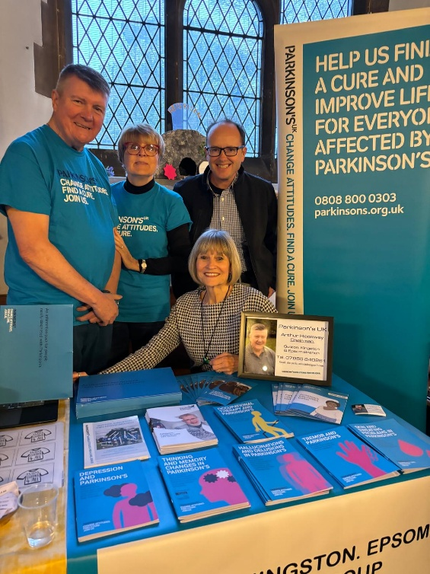
Events include:
Twice monthly singing groups/group speech therapy/exercise classes/coffee mornings/Summer Day trips/theatre visits/afternoon teas/Christmas dinner and New Year lunch and much more besides.

Parkinson's UK is the operating name of the Parkinson's Disease Society of the United Kingdom. A company limited by guarantee. Registered in England and Wales (00948776). registered office: 50 Broadway, London, SW1H 0DB. A charity registered in England and Wales (258197) and in Scotland (SCO37554)

